A Super Helpful Git Command!

I have a cool git command for you.

In your project, run this command to see a really nice log.

1. git log --topo-order --all --graph --date=local --pretty=format:'%C(green)%h%C(reset) %><(55,trunc)%s%C(red)%d%C(reset) %C(blue)[%an]%C(reset) %C(yellow)%ad%C(reset)%n'

I've been using this really cool git command for a long time called git lg. It's like git log but wayyyyyyyy better.

Here's the free code snippet, and what your .gitconfig file would look like when you add it to your global git config

[https://codingforeverybody.com/snippets/git-lg](https://codingforeverybody.com/snippets/git-lg" \t "_blank)

Here's a preview of the new git log you'll create:

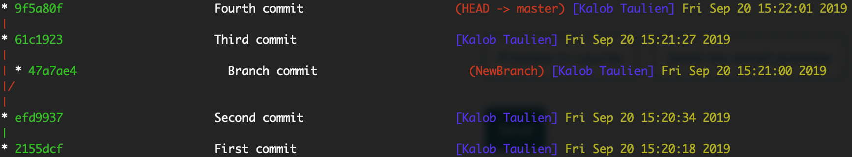

And here's what the default (and ugly, and hard to read) git log command usually looks like:

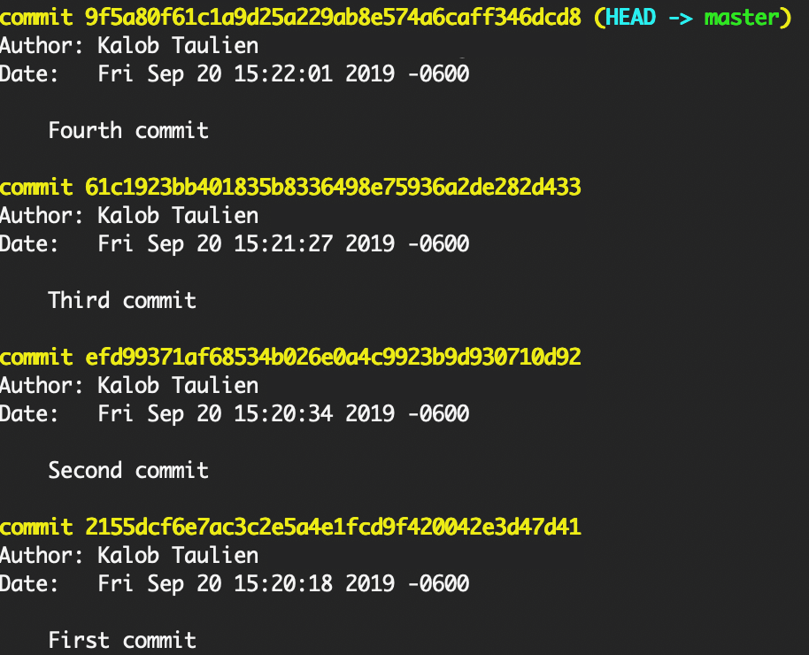

Happy coding!